Nuclear Missile Launch Circuit
Gold & Platinum Task
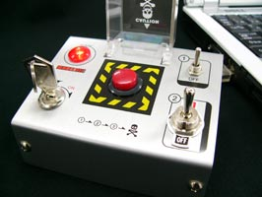

A nuclear missile can only be launched if the Prime Minister and two of three cabinet ministers give their permission. Using the codes below
a) Draw the truth table showing all the possible combinations for the inputs and output.
b) Write down a Boolean expression for L in terms of P, A, B and C
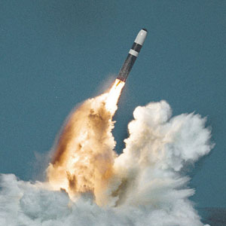
c) Build a logic circuit on logic.ly that is capable of carrying out the expression. Screen shot the final circuit.
Codes
P = Prime Minister's Permission
A = senior cabinet minister A's permission
B = senior cabinet minister B's permission
C = senior cabinet minister C's permission
L = nuclear missile launched

Truth Table
P | A | B | C | L

Boolean Algebra

Circuit

